**CSF 2113 Lab 3.1 Iterations**

1. **for loop statement in Python using a list of values**
2. What is the output of following code segment?

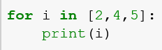

|  |
| --- |
| 2  4  5 |

1. What is the output of following code segment?

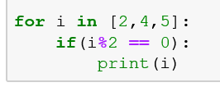

|  |
| --- |
| 2  4 |

1. What is the output of following code segment?

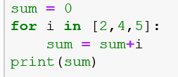

|  |
| --- |
| 11 |

1. What is the output of following code segment?

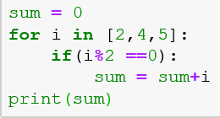

|  |
| --- |
| 6 |

1. What is the output of following code segment?

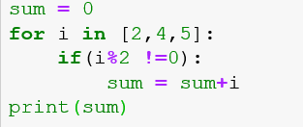

|  |
| --- |
| 5 |

1. What is the output of following code segment?

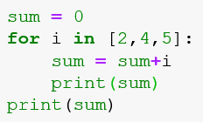

|  |
| --- |
| 2  6  11  11 |

1. What is the output of following code segment?

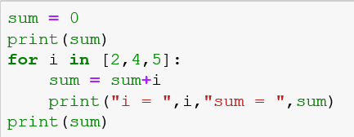

|  |
| --- |
| 0  i = 2 sum = 2  i = 4 sum = 6  i = 5 sum = 11  11 |

1. What is the output of following code segment?

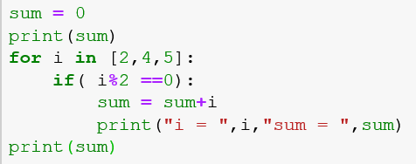

|  |
| --- |
| 0  i = 2 sum = 2  i = 4 sum = 6  6 |

1. **for loop statement in Python using range**
2. What is the output of following code segment?

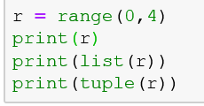

|  |
| --- |
| range(0, 4)  [0, 1, 2, 3]  (0, 1, 2, 3) |

1. What is the output of following code segment?

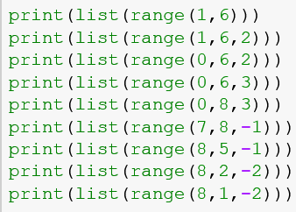

|  |
| --- |
| [1, 2, 3, 4, 5]  [1, 3, 5]  [0, 2, 4]  [0, 3]  [0, 3, 6]  []  [8, 7, 6]  [8, 6, 4]  [8, 6, 4, 2] |

1. What is the output of following code segment?

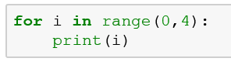

|  |
| --- |
| 0  1  2  3 |

1. What is the output of following code segment?

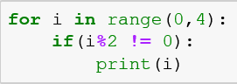

|  |
| --- |
| 1  3 |

1. What is the output of following code segment?

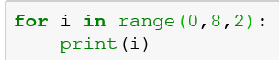

|  |
| --- |
| 0  2  4  6 |

1. What is the output of following code segment?

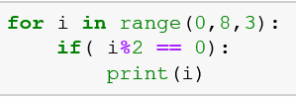

|  |
| --- |
| 0  6 |

1. What is the output of following code segment?

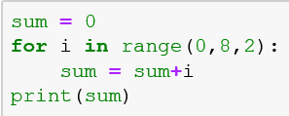

|  |
| --- |
| 4 |

1. What is the output of following code segment?

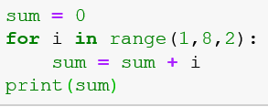

|  |
| --- |
| 4 |

1. What is the output of following code segment?

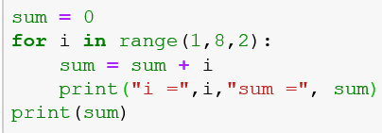

|  |
| --- |
| i = 1 sum = 1  i = 3 sum = 2  i = 5 sum = 3  i = 7 sum = 4  4 |

1. What is the output of following code segment?

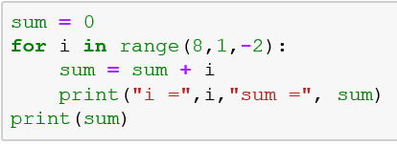

|  |
| --- |
| 0 |

1. **for loop statement in Python using range**
2. Write a program which take a range from the users and display all numbers in the range.

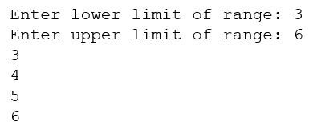

|  |
| --- |
| f=int(input("Enter lower limit of range: "))  t=int(input("Enter upper limit of range: "))  for i in range(f, t +1):  print(i)  Enter lower limit of range: 3  Enter upper limit of range: 6  3  4  5  6 |

1. Write a program which take a range from the users and display all odd numbers in the range.

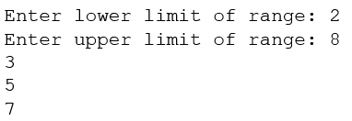

|  |
| --- |
| f=int(input("Enter lower limit of range: "))  t=int(input("Enter upper limit of range: "))  for i in range(f, t +1):  if(i%2!=0):  print(i)  Enter lower limit of range: 2  Enter upper limit of range: 8  3  5  7 |

1. Write a program which take a range from the users and display all numbers which are multiple of 5 in the given range.

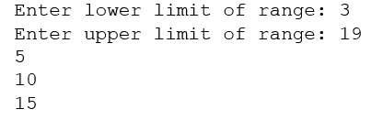

|  |
| --- |
| f=int(input("Enter lower limit of range: "))  t=int(input("Enter upper limit of range: "))  for i in range(f, t +1):  if(i%5==0):  print(i)  Enter lower limit of range: 3  Enter upper limit of range: 19  5  10  15 |

1. Write a program which take a range from the users and display sum of the numbers in the given range?

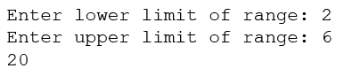

|  |
| --- |
| sum=0  f=int(input("Enter lower limit of range: "))  t=int(input("Enter upper limit of range: "))  for i in range(f, t +1):  sum=sum+i  print(i)  print(sum)  Enter lower limit of range: 2  Enter upper limit of range: 6  2  3  4  5  6  20 |

1. Write a program which take a range from the users and display sum of the all numbers which are multiple of 5 in the given range?

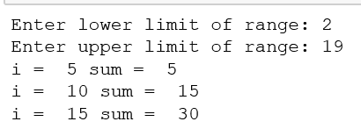

|  |
| --- |
| sum=0  f=int(input("Enter lower limit of range: "))  t=int(input("Enter upper limit of range: "))  for i in range(f, t +1):  if(i%5==0):  sum=sum+i  print("i= ",i,"sum= ",sum)  Enter lower limit of range: 2  Enter upper limit of range: 19  i= 5 sum= 5  i= 10 sum= 15  i= 15 sum= 30 |

**End of Lab**